**ABDUL NAFAY**

**I22-1605**

**COMPUTER NETWORKS**

**SEMESTER PROJECT**

**CISCO PACKET TRACER**

Overview :

This project was on the design and configuration of a complex network topology. The various subnetting techniques and routing protocols were used to satisfy specific host and network requirements. The focus was on using VLSM to optimize IP address allocation across multiple networks while making sure that there was efficient use of available IP addresses.

We had to configure multiple servers and routings and some protocols alng with ACL and NAT

Details:

* IP CONFIGURATION

This is IP configured on one router  
Similarly all routers are given IP’s on multiple interfaces according to VLSM

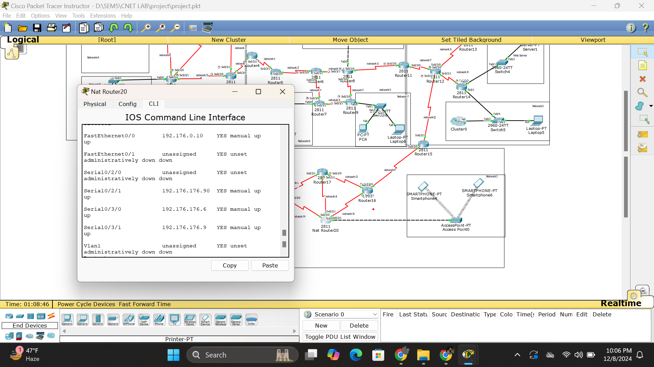

* ROUTING

Next step I performed was routing according to defined areas for RIP , OSPF and EIGRP

Here is provided screenshot of one router from each routing method

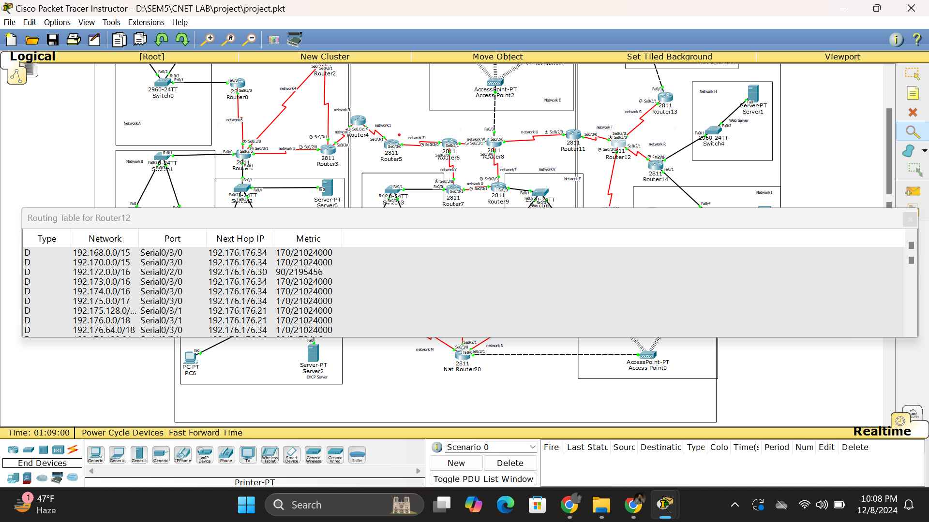

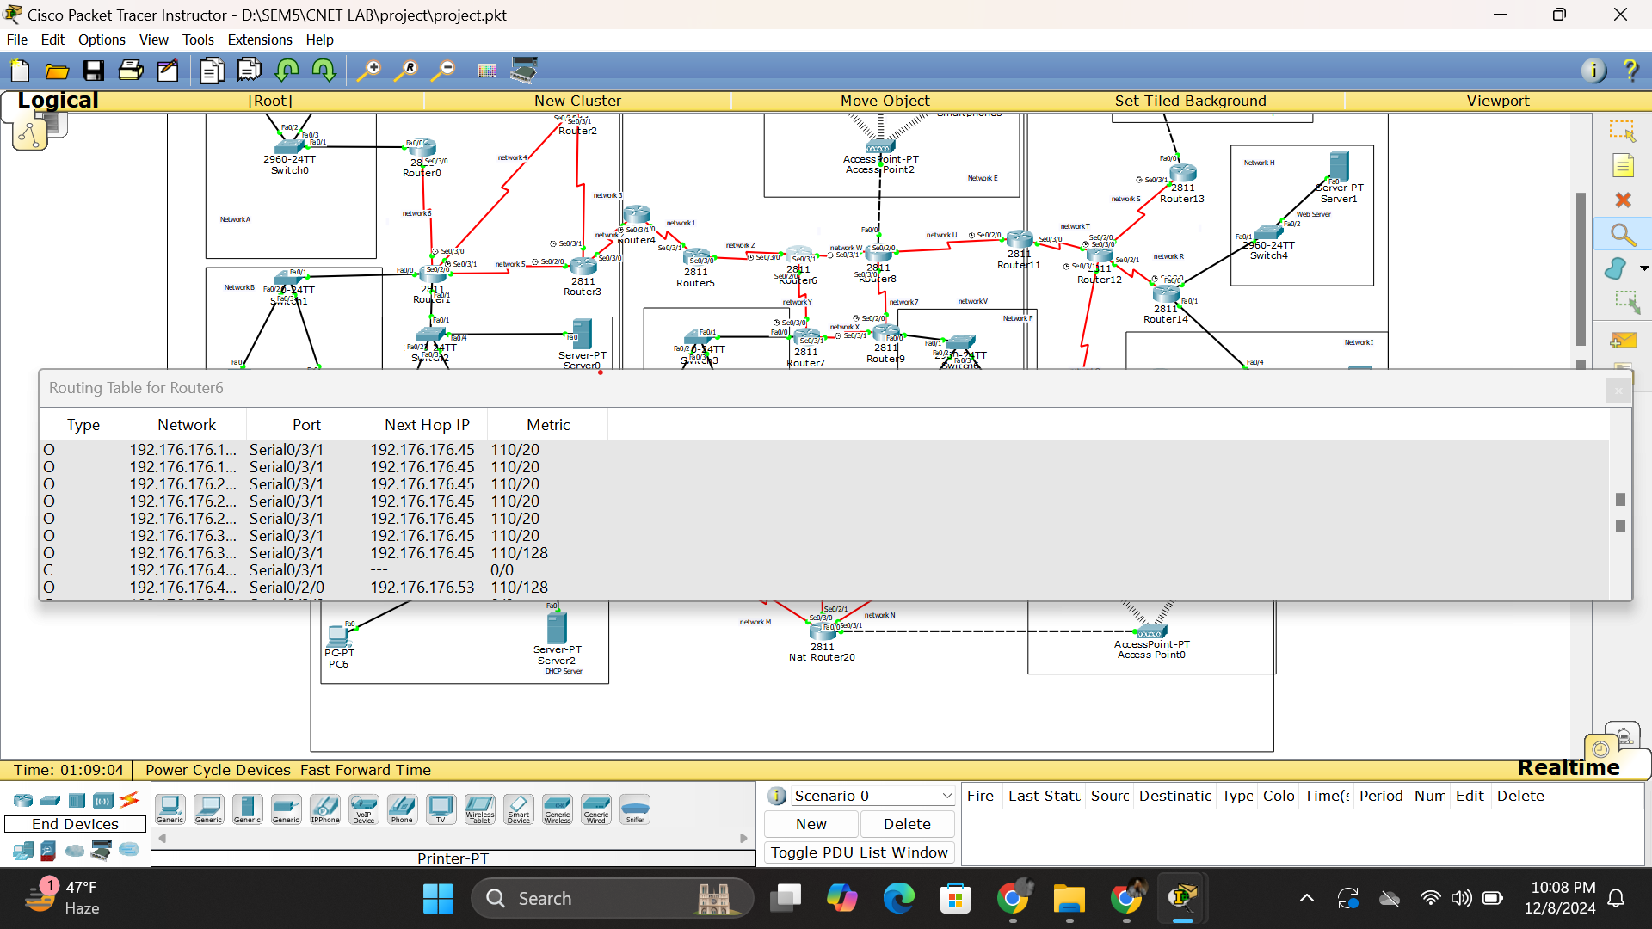

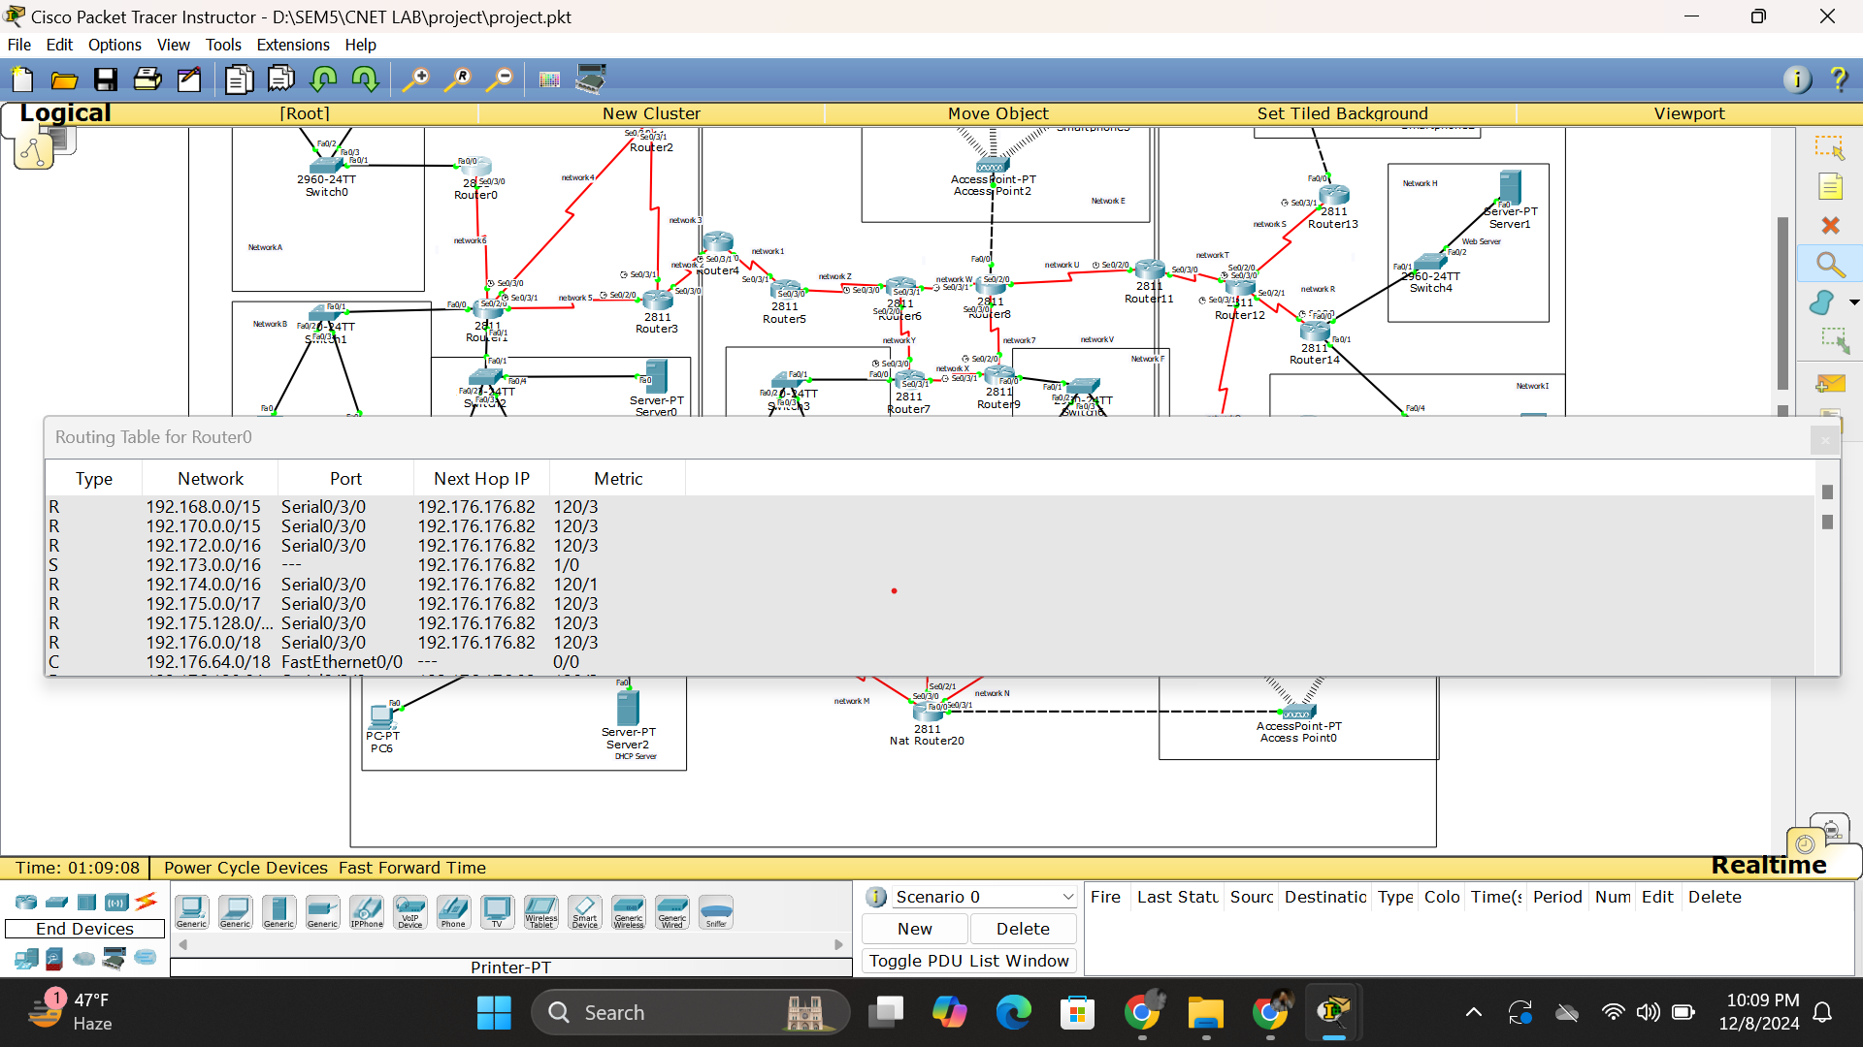

* REDISTRIBUTION

Next step was redistribution between different routing areas

I performed RIP-OSPF redistribution on 1 router and OSPF-EIGRP redistribution on 2 routers

Here is routing table screen shot of routers on which redistribution is performed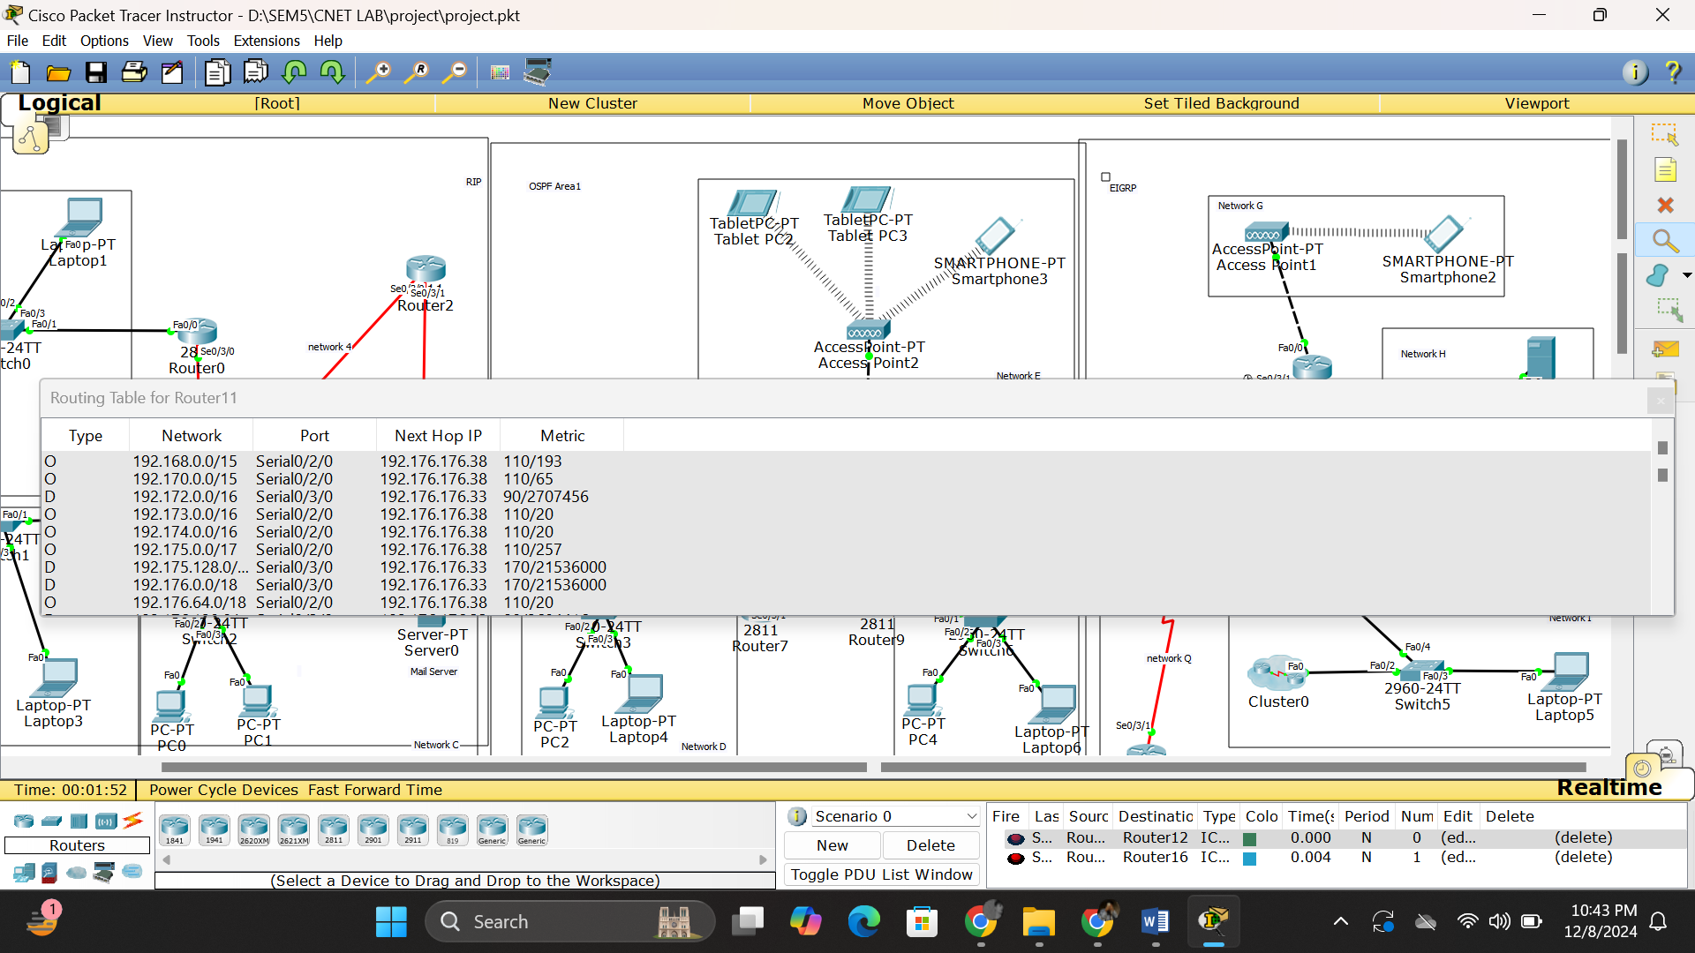

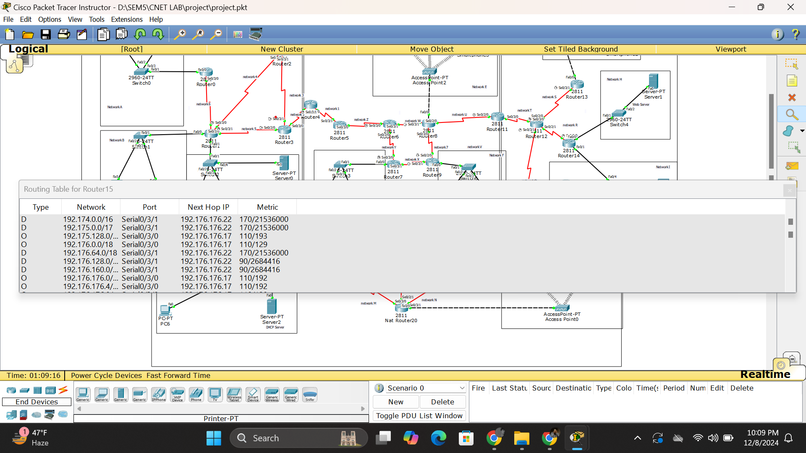

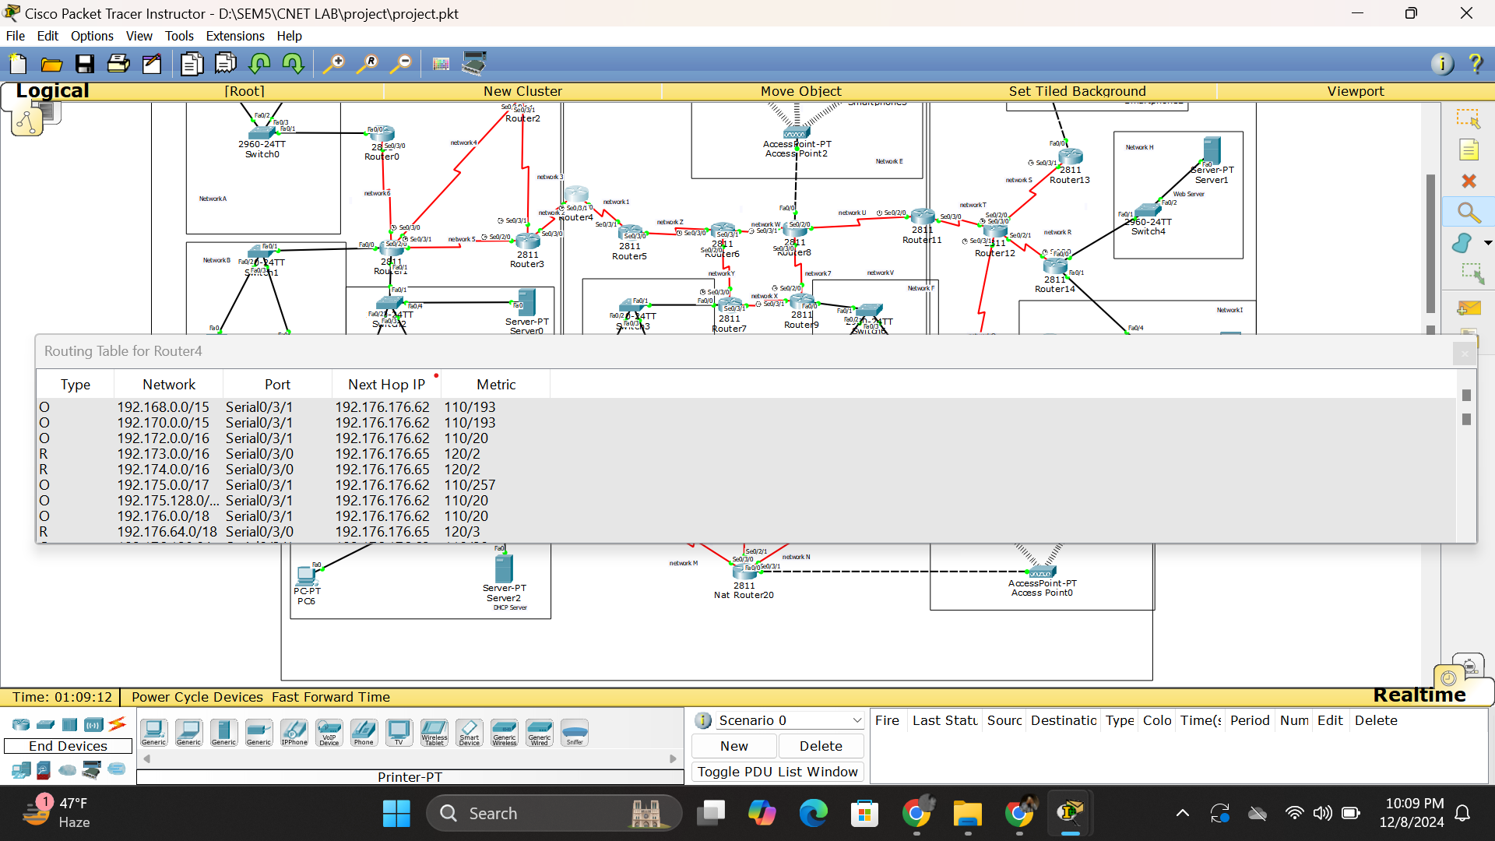

Successful packet transfer between routers having different routing techniques :

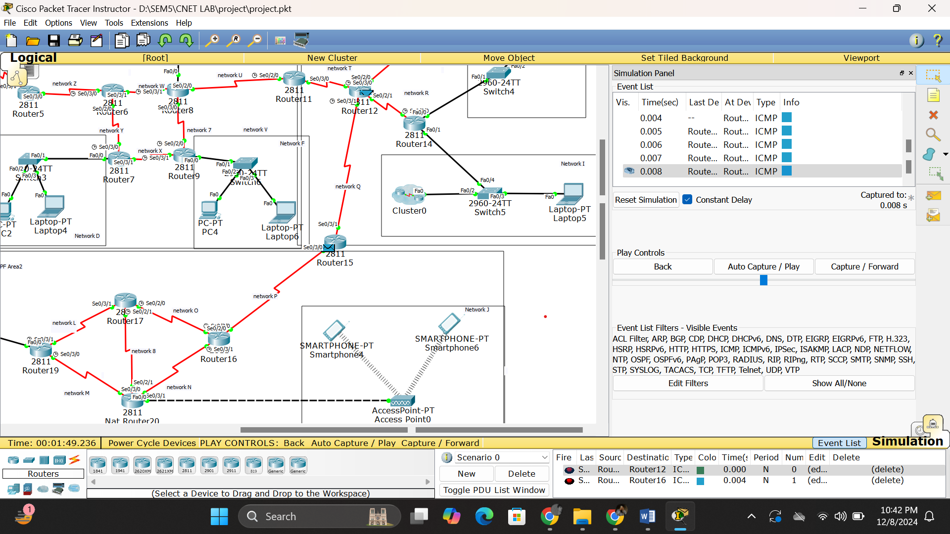

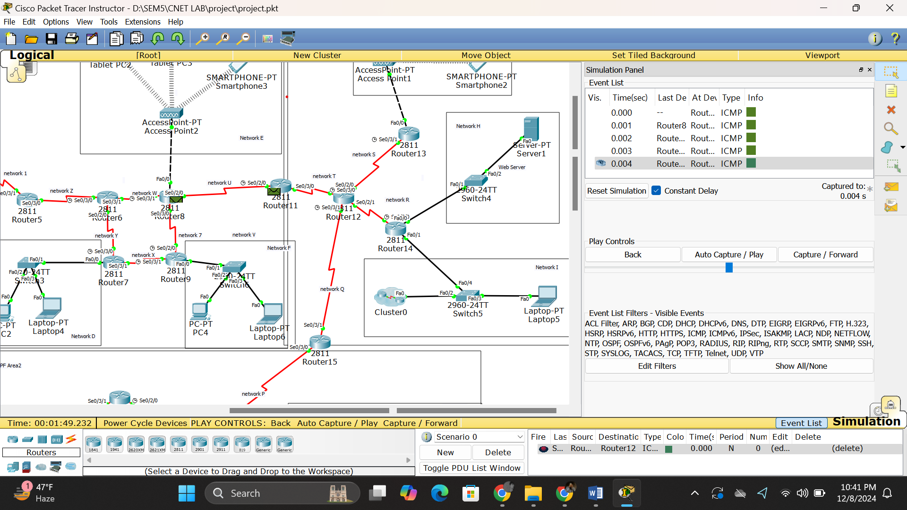

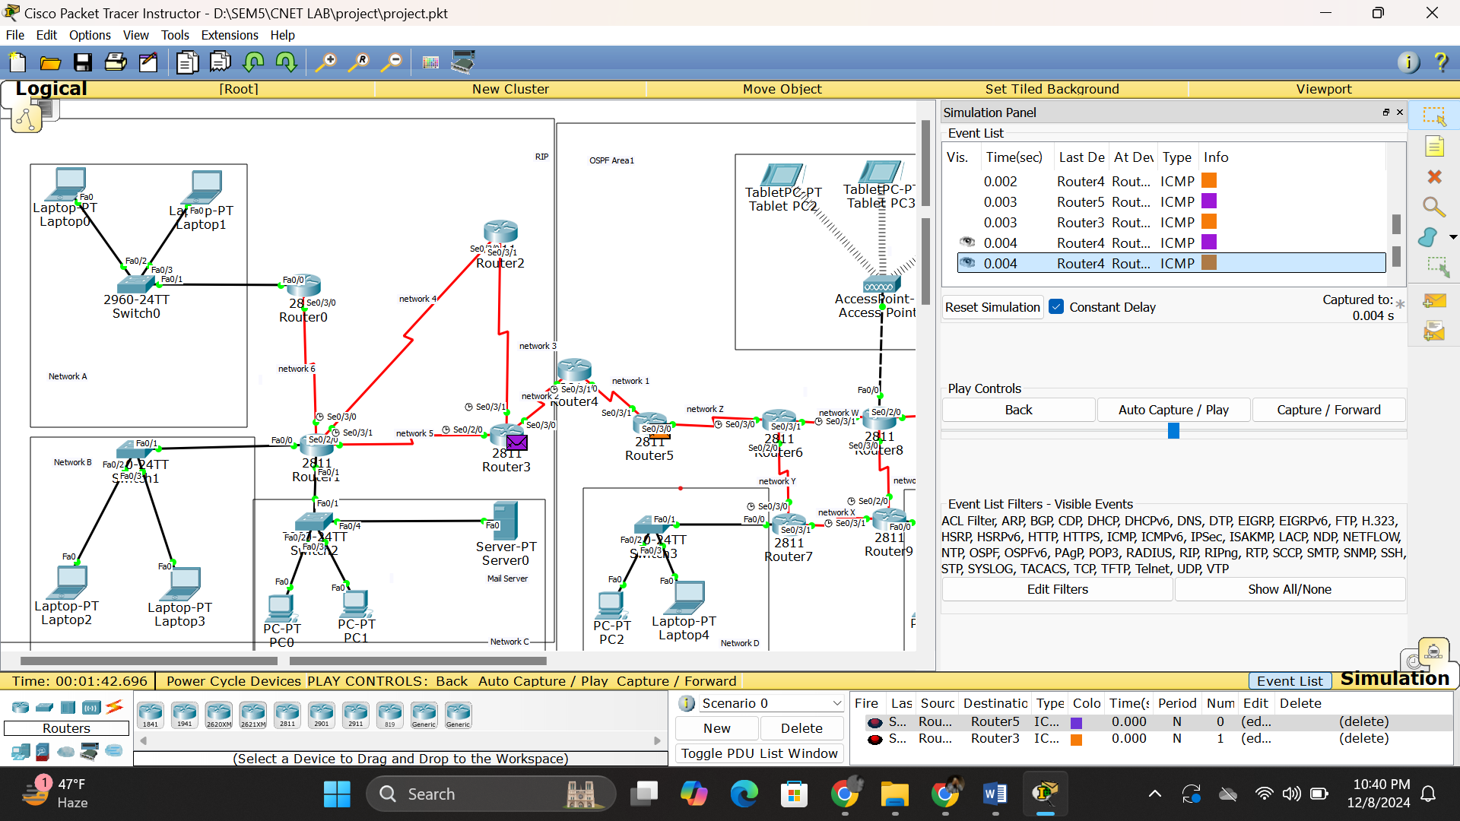

* DHCP

I added all networks in DHCP server along with subnet masks and DNS server (mail server)

DHCP ip configuration on end-device: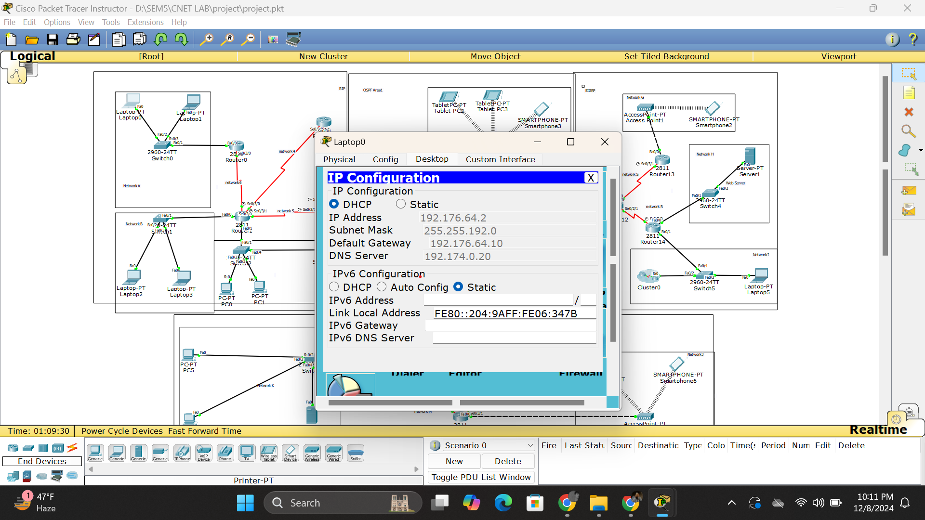

SERVER:

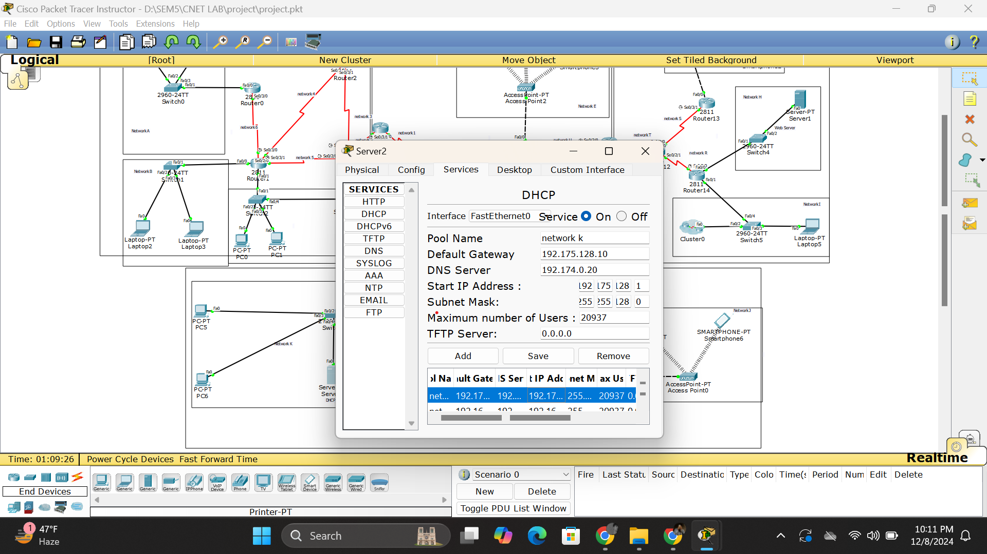

* SMTP

Enabled mail transferring from any end device to any end device in my topology

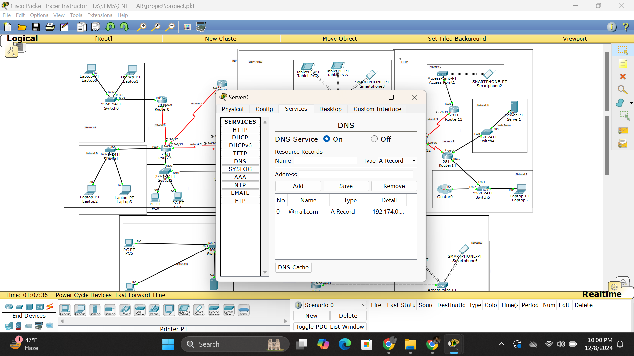

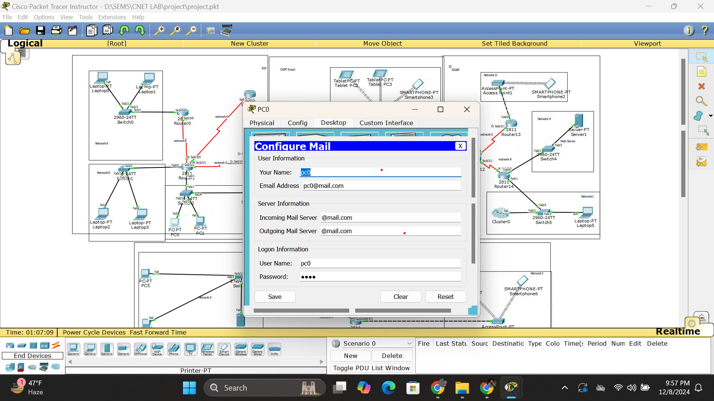

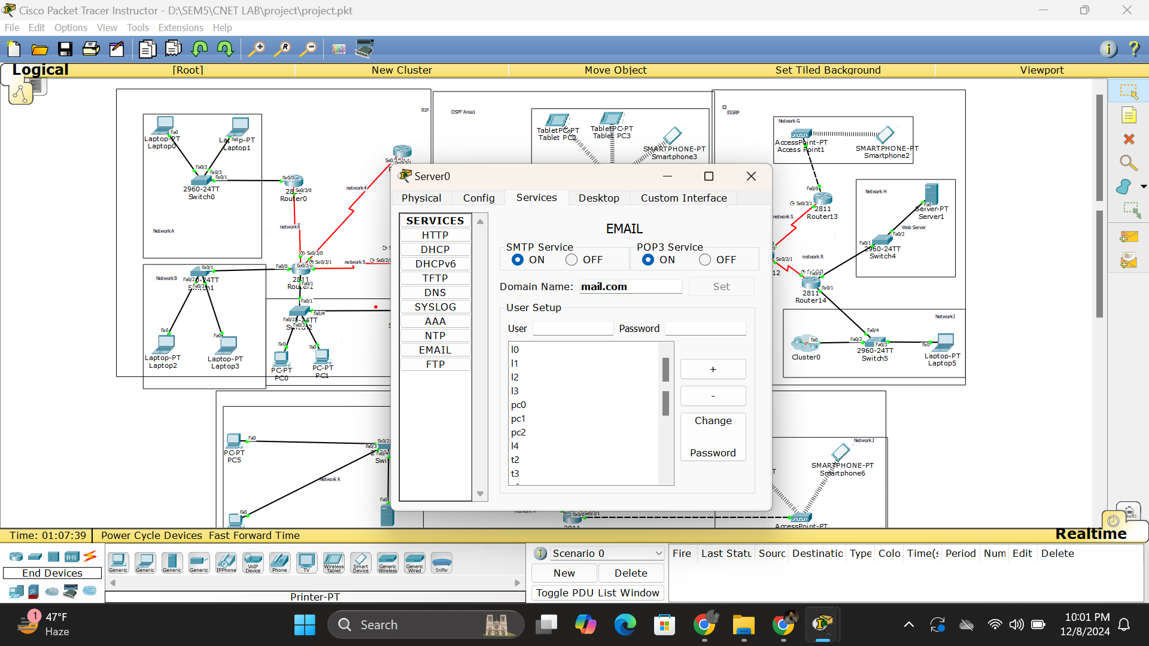

* ACL

Blocked web browsing from given devices and D network

